Main content
Appendix
A

Safety Procedures and Environmental Concerns
- Appendix Introduction
- Measures and Properties of Electricity
- Protecting Yourself
- Protecting the Equipment
- Protecting the Environment
- Key Terms
- Hands-On Projects
Change font size
help

Main content

Appendix Introduction
This appendix covers how to stay safe and protect equipment and the environment as you perform the duties of an IT support technician. We begin by understanding the properties and dangers of electricity.
Change font size
help

Main content

Measures and Properties of Electricity
A+ Core 2
4.4, 4.5
In our modern world, we take electricity for granted, and we miss it terribly when it’s cut off. Nearly everyone depends on it, but few really understand it. A successful hardware technician does not expect to encounter failed processors, fried motherboards, smoking monitors, or frizzed hair. To avoid these excitements, you need to understand how to measure electricity and how to protect computer equipment from its damaging power.
Let’s start with the basics. To most people, volts, ohms, joules, watts, and amps are vague terms that simply mean electricity. All these terms can be used to measure some characteristic of electricity, as listed in Table A-1.
Table A-1

Measures of Electricity
Unit | Definition | Computer Example
Volt (for example, 115 V) | Electrical force is measured in volts. The symbol for volts is V. | A power supply steps down the voltage from 115-V house current to levels of 3.3, 5, and 12 V that computer components can use.
Amp or ampere (for example, 1.5 A) | An amp is a measure of electrical current. The symbol for amps is A. | An LCD monitor requires about 5 A to operate. A small laser printer uses about 2 A. An optical drive uses about 1 A.
Ohm (for example, 20 Ω) | An ohm is a measure of resistance to electricity. The symbol for ohm is Ω. | Current can flow in typical computer cables and wires with a resistance of near zero Ω.
Joule (for example, 500 J) | A joule is a measure of work or energy. One joule (pronounced “jewel”) is the work required to push an electrical current of 1 A through a resistance of 1 Ω. The symbol for joule is J. | A surge suppressor (see Figure A-1) is rated in joules—the higher the better. The rating determines how much work a device can expend before it can no longer protect the circuit from a power surge.
Watt (for example, 20 W) | A watt is a measure of the total electrical power needed to operate a device. One watt is one joule per second. Watts can be calculated by multiplying volts by amps. The symbol for watts is W. | The power consumption of an LCD computer monitor is rated at about 14 W. A DVD burner uses about 25 W when burning a DVD.
Figure A-1
A surge suppressor protects electrical equipment from power surges and is rated in joules
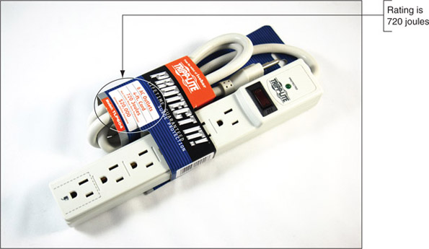
Notes
To learn more about how volts, amps, ohms, joules, and watts measure the properties of electricity, see “Electricity and Multimeters” in the online content that accompanies this text at cengage.com. To find out how to access this content, see the Preface to this text.
Now let’s look at how electricity gets from one place to another and how it is used in house circuits and computers.

AC and DC
A+ Core 2
4.4, 4.5
Electricity can be either AC or DC. Alternating current (AC) goes back and forth, or oscillates, rather than traveling in only one direction. House current in the United States is AC and oscillates 60 times in one second (60 hertz). Voltage in the system is constantly alternating from positive to negative, which causes the electricity to flow first in one direction and then in the other. Voltage alternates from +115 V to −115 V. AC is the most economical way to transmit electricity to our homes and workplaces. By decreasing current and increasing voltage, we can force alternating current to travel great distances. When alternating current reaches its destination, it is made more suitable for driving our electrical devices by decreasing voltage and increasing current.
Direct current (DC) travels in only one direction and is the type of current that most electronic devices require, including computers. A rectifier is a device that converts AC to DC, and an inverter is a device that converts DC to AC. A transformer is a device that changes the ratio of voltage to current. The power supply used in computers is both a rectifier and a transformer.
Large transformers reduce the high voltage on power lines coming to your neighborhood to a lower voltage before the current enters your home. The transformer does not change the amount of power in this closed system; if it decreases voltage, it increases current. The overall power stays constant, but the ratio of voltage to current changes, as illustrated in Figure A-2.
Figure A-2
A transformer keeps power constant but changes the ratio of current to voltage
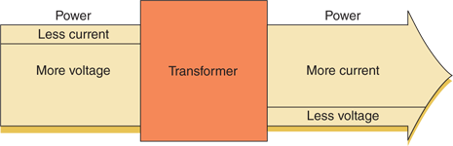
Again, direct current flows in only one direction. Think of electrical current like a current of water that flows from a state of high pressure to a state of low pressure or rest. Electrical current flows from a high-pressure state (called hot) to a state of rest (called ground or neutral). For a power supply, a power line may be either +5 or −5 volts in one circuit or +12 or −12 volts in another circuit. The positive or negative value is determined by how the circuit is oriented, either on one side of the power output or the other. Several circuits coming from the power supply accommodate different devices with different power requirements.

Hot, Neutral, and Ground
A+ Core 2
4.4, 4.5
AC travels on a hot line from a power station to a building and returns to the power station on a neutral line. When the two lines reach the building and enter an electrical device, such as a lamp, the device controls the flow of electricity between the hot and neutral lines. If an easier path (one with less resistance) is available, the electricity follows that path. This can cause a short, a sudden increase in flow that can also create a sudden increase in temperature—enough to start a fire and injure both people and equipment. Never put yourself in a position where you are the path of least resistance between the hot line and ground!
Caution
It’s very important that PC components be properly grounded. Never connect a PC to an outlet or use an extension cord that doesn’t have the third ground plug. The third line can prevent a short from causing extreme damage. In addition, the bond between the neutral and ground helps eliminate electrical noise (stray electrical signals) within the PC that is sometimes caused by other nearby electrical equipment.
To prevent uncontrolled electricity in a short, the neutral line is grounded. Grounding a line means that the line is connected directly to the earth; in the event of a short, the electricity flows into the earth and not back to the power station. Grounding serves as an escape route for out-of-control electricity because the earth is always capable of accepting a flow of current. With computers, a surge suppressor can be used to protect them and their components against power surges.
Caution
Beware of the different uses of black wire. In desktop computers and in DC circuits, black is used for ground, but in home wiring and in AC circuits, black is used for hot!
The neutral line to your house is grounded many times along its way (in fact, at each electrical pole) and is also grounded at the breaker box where the electricity enters your house. You can look at a three-prong plug and see the three lines: hot, neutral, and ground (see Figure A-3).
Figure A-3
A polarized plug showing hot and neutral, and a three-prong plug showing hot, neutral, and ground
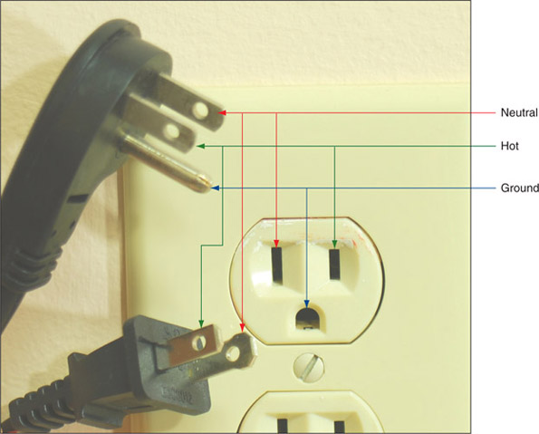
Notes
House AC voltage in the United States is about 110–120 V, but know that in other countries, this is not always the case. In many other countries, the standard is 220 V. Outlet styles also vary from one country to the next.
Now that you know about electricity, you will learn how to protect yourself against the dangers of electricity and other factors that might harm you as you work around computers.
Change font size
help

Main content

Protecting Yourself
A+ Core 2
4.4, 4.5
To protect yourself against electrical shock when working with any electrical device, including computers, printers, scanners, and network devices, disconnect the power if you notice a dangerous situation that might lead to electrical shock or fire. When you disconnect the power, do so by pulling on the plug at the AC outlet. To protect the power cord, don’t pull on the cord itself. Also, don’t just turn off the on/off switch on the device; you need to actually disconnect the power. Note that any of the following can indicate a potential danger:
- You notice smoke coming from the computer case or the case feels unusually warm.
- The power cord is frayed or otherwise damaged in any way.
- Water or other liquid is on the floor around the device or was spilled on it.
- The device has been exposed to excess moisture.
- The device has been dropped or you notice physical damage.
- You smell a strong electronics odor.
- The power supply or fans are making a whining noise.

Safely Working Inside Computers, Printers, and Other Electrical Devices
A+ Core 2
4.4, 4.5
To stay safe, always do the following before working inside computers, printers, and other electrical devices:
- Remove jewelry. Remove any jewelry that might come in contact with components. Jewelry is commonly made of metal and might conduct electricity if it touches a component. It can also get caught in cables and cords inside computer cases.
- Power down the system and unplug it. For a computer, unplug the power, monitor, mouse, and keyboard cables, unplug any other peripherals or cables attached, and move them out of your way.
- For a computer, press and hold down the power button for a moment. After you unplug the computer, press the power button for about three seconds to completely drain the power supply. Sometimes when you do so, you’ll hear the fans quickly start and go off as residual power is drained. Only then is it safe to work inside the case.

Electrical Fire Safety
A+ Core 2
4.4, 4.5
Never use water to put out a fire fueled by electricity because water is a conductor and you might get a severe electrical shock. A computer lab needs a fire extinguisher that is rated to put out electrical fires. Fire extinguishers are rated by the type of fires they put out:
- Class A extinguishers can use water to put out fires caused by wood, paper, and other combustibles.
- Class B extinguishers can put out fires caused by liquids such as gasoline, kerosene, and oil.
- Class C fire extinguishers use nonconductive chemicals to put out a fire caused by electricity. See Figure A-4.
Figure A-4
A Class C fire extinguisher is rated to put out electrical fires
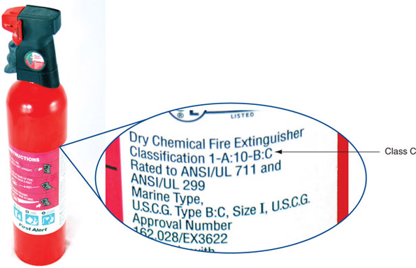

Proper Use of Cleaning Pads and Solutions
A+ Core 2
4.4, 4.5
As a support technician, you’ll find yourself collecting different cleaning solutions and cleaning pads to clean a variety of devices, including the mouse and keyboard, CDs, DVDs, Blu-ray discs and their drives, and monitors. Figure A-5 shows a few of these products. For example, the contact cleaner in the figure is used to clean the contacts on the edge connectors of expansion cards; a good cleaning can solve a problem with a faulty connection.
Figure A-5
Cleaning solutions and pads

Most of these cleaning solutions contain flammable and poisonous materials. Take care when using them so that they don’t get on your skin or in your eyes. To find out what to do if you are accidentally exposed to a dangerous solution, look at the instructions printed on the can or check out the material safety data sheet (see Figure A-6). A material safety data sheet (MSDS) explains how to properly handle substances such as chemical solvents and how to dispose of them.
Figure A-6
Each chemical you use should have a material safety data sheet available
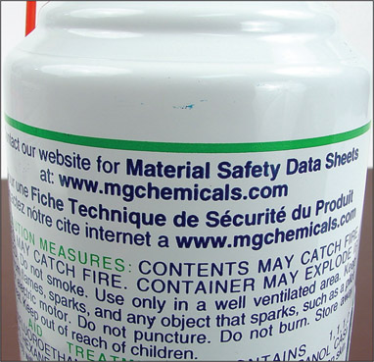
An MSDS includes information such as physical data, toxicity, health effects, first aid, storage, shipping, disposal, and spill procedures. The MSDS comes packaged with the chemical; you can also order one from the manufacturer or find one on the Internet (see ilpi.com/msds).
A+ Exam Tip
The A+ Core 2 exam expects you to know how to use MSDS documentation to dispose of chemicals and help protect the environment. You also need to know that you must follow all local government regulations when disposing of chemicals and other materials dangerous to the environment.
If you have an accident with cleaning solutions or other dangerous products, your company or organization might require you to report the accident and/or fill out an incident report. Check with your organization to find out how to report these types of incidents.

Managing Cables
A+ Core 2
4.4, 4.5
People can trip over cables or cords left on the floor, so be careful that cables are in a safe place. If you must run a cable across a path or where someone sits, use a cable or cord cover that can be nailed or screwed to the floor. Don’t leave loose cables or cords in a traffic area where people can trip over them; such objects are called trip hazards.

Lifting Heavy Objects
A+ Core 2
4.4, 4.5
Back injury caused by lifting heavy objects is one of the most common work injuries. Whenever possible, put heavy objects, such as a large laser printer, on a cart to move them. If you do need to lift a heavy object, follow these guidelines to keep from injuring your back:
- Look at the object and decide which side of it to face so that the load will be the most balanced when you lift it.
- Stand close to the object with your feet apart.
- Keeping your back straight, bend your knees and grip the load.
- Lift with your legs, arms, and shoulders, not with your back or stomach.
- Keep the load close to your body and avoid twisting your body while you’re holding the load.
- To put the object down, keep your back as straight as you can and lower the object by bending your knees.
Don’t try to lift an object that is too heavy for you. Because there are no exact guidelines for when heavy is too heavy, use your best judgment as to when to ask for help.

Safety Goggles and Air Filter Mask
A+ Core 2
4.4, 4.5
If you work in a factory environment where flying fragments, chips, or other particles are about, your employer might require that you wear safety goggles to protect your eyes. In addition, if the air is filled with dust or other contaminants, your employer might require you to wear an air-purifying respirator, commonly called an air filter mask, which filters out the dust and other contaminants. If safety goggles or a mask is required, your employer is responsible for providing one that is appropriate for your work environment.
Change font size
help

Main content

Protecting the Equipment
A+ Core 2
4.4, 4.5
As you learn to troubleshoot and solve computer problems, you gradually begin to realize that many of them could have been avoided by good computer maintenance, which includes protecting the computer against environmental factors such as humidity, dust, and out-of-control electricity.

Protecting the Equipment Against Static Electricity or ESD
A+ Core 2
4.4, 4.5
Suppose you come indoors on a cold day, pick up a comb, and touch your hair. Sparks fly! What happened? Static electricity caused the sparks. Electrostatic discharge (ESD), commonly known as static electricity, is an electrical charge at rest. When you came indoors, this charge built up on your hair and had no place to go. An ungrounded conductor (such as wire that is not touching another wire) or a nonconductive surface (such as your hair) holds a charge until it is released. When two objects with dissimilar electrical charges touch, electricity passes between them until the dissimilar charges become equal.
To see static charges equalizing, turn off the lights in a room, scuff your feet on the carpet, and touch another person. Occasionally, you can see and feel the charge in your fingers. If you can feel the charge, you discharged at least 1500 volts of static electricity. If you hear the discharge, you released at least 6000 volts. If you see the discharge, you released at least 8000 volts of ESD. A charge of only 10 volts can damage electronic components! You can touch a chip on an expansion card or motherboard, damage the chip with ESD, and never feel, hear, or see the electrical discharge.
ESD can cause two types of damage in an electronic component: catastrophic failure and upset failure. A catastrophic failure destroys the component beyond use. An upset failure damages the component so that it does not perform well, even though it may still function to some degree. Upset failures are more difficult to detect because they are not consistent and not easily observed. Both types of failures permanently affect the device. Components are easily damaged by ESD, but because the damage might not show up for weeks or months, a technician is likely to get careless and not realize the damage he or she is doing.
Caution
Unless you are measuring power levels with a multimeter or power supply tester, never touch a component or cable inside a computer case while the power is on. The electrical voltage is not enough to seriously hurt you but is more than enough to permanently damage the component.
Before touching or handling a component (for example, a hard drive, motherboard, expansion card, processor, or memory modules), protect it against ESD by always grounding yourself first. You can ground yourself and the computer parts by using one or more of the following static control devices or methods:
- ESD strap. An ESD strap, also called a ground bracelet, antistatic wrist strap, or ESD bracelet, is a strap you wear around your wrist. The strap has a cord attached with an alligator clip on the end. Attach the clip to the computer case you’re working on, as shown in Figure A-7. Any static electricity between you and the case will be discharged. Therefore, as you work inside the case, you will not damage the components with static electricity. The bracelet also contains a resistor that prevents electricity from harming you.
Figure A-7
A ground bracelet, which protects computer components from ESD, can clip to the side of the computer case and eliminate ESD between you and the case
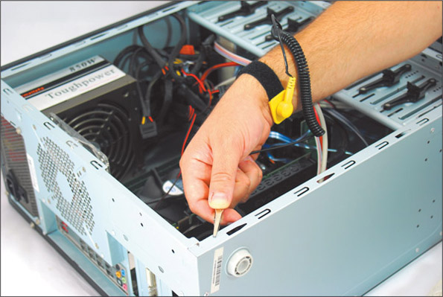
Caution
When working on a laser printer, don’t wear the ESD strap because you don’t want to be the ground for these high-voltage devices.
- Ground mats. A ground mat, also called an ESD mat, dissipates ESD and is commonly used by bench technicians (also called depot technicians) who repair and assemble computers at their workbenches or in an assembly line. Ground mats have a connector in one corner that you can use to connect the mat to the ground (see Figure A-8). If you lift a component off the mat, it is no longer grounded and is susceptible to ESD, so it’s important to use an ESD strap with a ground mat.
Figure A-8
An ESD mat dissipates ESD and should be connected to the ground
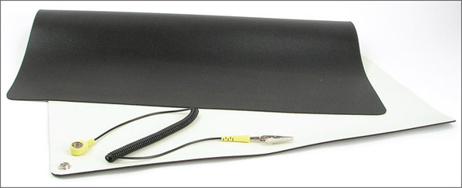
- Static shielding bags. New components come shipped in static shielding bags, also called antistatic bags. These bags are a type of Faraday cage, named after Michael Faraday, who built the first cage in 1836. A Faraday cage is any device that protects against an electromagnetic field. Save the bags to store other devices that belong in a computer but are not currently installed. As you work on a computer, know that a device is not protected from ESD if you place it on top of the bag; the protection is inside the bag (see Figure A-9).
Figure A-9
An antistatic bag helps protect components from ESD
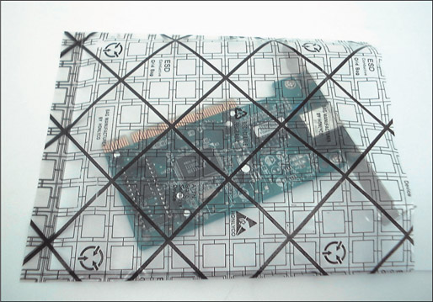
Caution
An older CRT monitor can also damage components with ESD. Don’t place or store expansion cards on top of or next to a CRT monitor, which can discharge as much as 29,000 volts onto the screen.
The best way to guard against ESD is to use an ESD strap together with a ground mat. Consider an ESD strap essential equipment when working on a computer. However, if you are in a situation in which you must work without one, touch the computer case or the power supply before you touch a component in the case, which is called self-grounding. Self-grounding dissipates any charge between you and whatever you touch. Here are some rules that can help protect computer parts against ESD:
- When passing a circuit board, memory module, or other sensitive component to another person, ground yourself and then touch the other person before you pass the component.
- Leave components inside their protective bags until you are ready to use them.
- Work on hard floors, not carpet, or use antistatic spray on the carpet.
- Don’t work on a computer if you or the computer has just come in from the cold because there is more danger of ESD when the atmosphere is cold and dry.
- When unpacking hardware or software, remove the packing tape and cellophane from the work area as soon as possible because these materials attract ESD.
- Keep components away from your hair and clothing.
A+ Exam Tip
The A+ Core 2 exam emphasizes that you should know how to protect computer equipment as you work on it, including how to protect components against damage from ESD.

Physically Protecting Your Equipment from the Environment
A+ Core 2
4.4, 4.5
When you protect equipment from ongoing problems with the environment, you are likely to have fewer problems later, and you will have less troubleshooting and repair to do. Here is how you can physically protect a computer:
- Protect a computer against dust and other airborne particles. When a computer must sit in a dusty environment, around those who smoke, or where pets might leave hair, you can:
  - Use a plastic keyboard cover to protect the keyboard. When the computer is turned off, protect the entire system with a cover or enclosure.
  - Install air filters over the front or side vents of the case where air flows in. Put your hand over the case of a running computer to feel where the air flows in. For most systems, air flows in from the front vents or vents on the side of the case that is near the processor cooler. The air filter shown in Figure A-10 has magnets that hold the filter to the case when screw holes are not available.
Figure A-10
This air filter is designed to fit over a case fan, power supply fan, or panel vent on the case
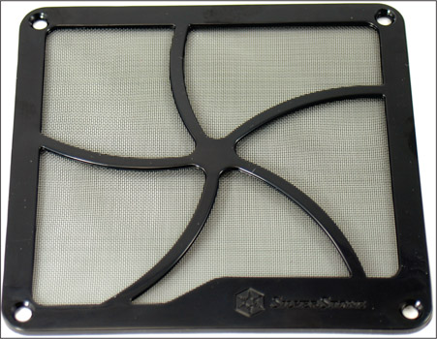
Notes
When working at a customer site, be sure to clean up any mess you created by blowing dust out of a computer case or keyboard.
  - Use compressed air or an antistatic vacuum (see Figure A-11) to remove dust from inside the case, if you have the case cover open. Figure A-12 shows a case fan that jammed because of dust and caused a system to overheat. While you’re cleaning up dust, don’t forget to blow or vacuum out the keyboard.
Figure A-11
An antistatic vacuum is designed to work inside sensitive electronic equipment such as computers and printers
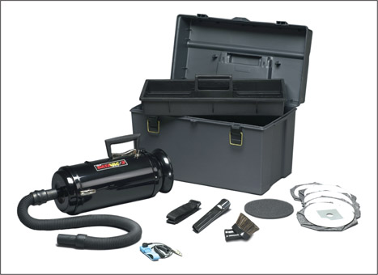
Figure A-12
This dust-jammed case fan caused a system to overheat
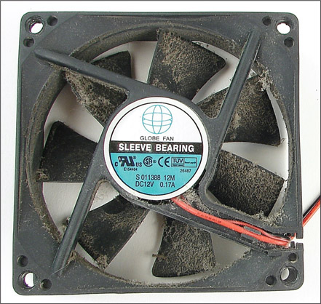
- Allow for good ventilation inside and outside the system. Proper air circulation is essential to keeping a system cool. Don’t block air vents on the front and rear of the computer case or on the monitor. Inside the case, make sure cables are tied up and out of the way so as to allow for airflow and not obstruct fans from turning. Put covers on expansion slot openings at the rear of the case and put faceplates over empty bays on the front of the case. Don’t set a tower case directly on thick carpet because the air vent on the bottom front of the case can be blocked. If you are concerned about overheating, monitor temperatures inside and outside the case.
A+ Exam Tip
The A+ Core 2 exam expects you to know how to keep computers and monitors well ventilated and to use protective enclosures and air filters to protect the equipment from airborne particles.
- High temperatures and humidity can be dangerous for hard drives. I once worked in a basement with PCs, and hard drives failed much too often. After we installed dehumidifiers, the hard drives became more reliable. If you suspect a problem with room humidity, you can monitor it using a hygrometer. High temperatures can also damage computer equipment, and you should take precautions not to allow a computer to overheat.
Notes
A server room where computers stay and people don’t stay for long hours is usually set to balance what is good for the equipment and to conserve energy. Low temperatures and moderate humidity are best for the equipment, although no set standards exist for either. Temperatures might be set from 65 to 70 degrees F, and humidity between 30 percent and 50 percent, although some companies keep their server rooms at 80 degrees F to conserve energy. A data center where both computers and people stay is usually kept at a comfortable temperature and humidity for humans.
- Protect electrical equipment from power surges. Lightning and other electrical power surges can destroy computers and other electrical equipment. If a house or office building does not have surge protection equipment installed at the breaker box, be sure to install a protective device at each computer. The least expensive device is a power strip that is also a surge suppressor, although you might want to use an uninterruptible power supply for added protection.
Lightning can also get to your equipment across network cabling coming in through an Internet connection. To protect against lightning, use a surge suppressor such as the one shown in Figure A-13 in line between the ISP device (for example, a DSL modem or cable modem) and the computer or home router to protect it from spikes across the network cables. Notice the cord on the surge suppressor, which connects it to ground.
Figure A-13
A surge protector by APC for Ethernet lines
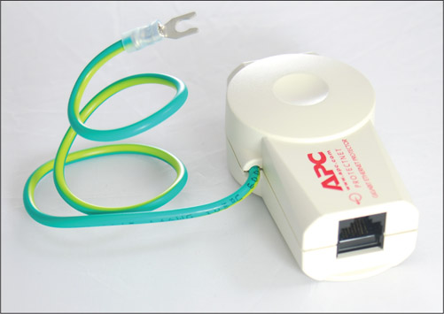
An uninterruptible power supply (UPS) is a device that raises the voltage when it drops during brownouts or sags (temporary voltage reductions). A UPS also does double duty as a surge suppressor to protect the system against power surges or spikes. In addition, a UPS can serve as a battery backup to provide enough power for a brief time during a total blackout so you can save your work and shut down the system. A UPS is not as essential for a laptop computer as it is for a desktop because a laptop has a battery that can sustain it during a blackout. Also, consider using a UPS to protect power to a router, switch, or other essential network device.
A common UPS device is a rather heavy box that plugs into an AC outlet and provides one or more electrical outlets and perhaps Ethernet and USB ports (see Figure A-14). It has an on/off switch, requires no maintenance, and is very simple to install. Use it to provide uninterruptible power to your desktop computer, monitor, and essential network devices. It’s best not to connect a UPS to nonessential devices such as a laser printer or scanner. The UPS shown in Figure A-14 has a USB port so that a computer can monitor power management and network ports to block harmful voltage on the network.
Figure A-14
The front and rear of an uninterruptible power supply (UPS)
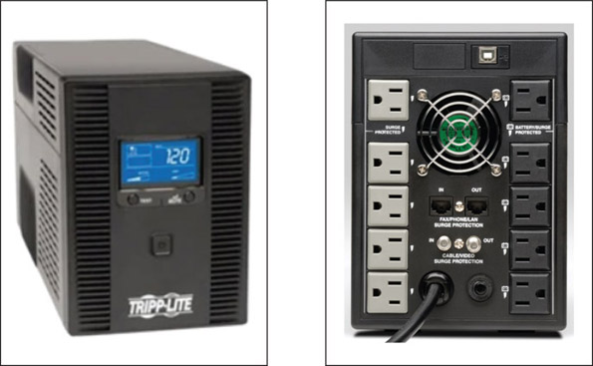
Source: dell.com
Notes
If a power outage occurs and you don’t have a reliable power conditioner installed at the breaker box in your house or building, unplug all power cords to the computers, printers, monitors, and peripherals. Sometimes when the power returns, sudden spikes are accompanied by another brief outage. You don’t want to subject your equipment to these surges. When buying a surge suppressor, look for one that guarantees against damage from lightning and that reimburses for equipment destroyed while the surge suppressor is in use.
Change font size
help

Main content

Protecting the Environment
A+ Core 2
4.4, 4.5
IT support technicians need to be aware that they can do damage to the environment if they dispose of used computer equipment improperly. As a support technician, one day you’re sure to face an assortment of useless equipment and consumables (see Figure A-15). Before you decide to trash it all, take a moment and ask yourself if some of the equipment can be donated or at least recycled. Think about fixing up an old computer and donating it to an underprivileged middle school student. If you don’t have the time for that, consider donating to the local computer repair class. The class can fix up such computers as a class project and donate them to young students.
Figure A-15
Keep, trash, recycle, or donate?
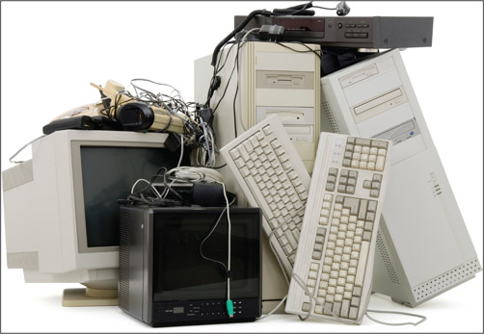
When disposing of any type of equipment or consumables, make sure to comply with local government environmental regulations. Table A-2 lists some items and how to dispose of them.
Table A-2

Computer Parts and How to Dispose of Them
Parts | How to Dispose of Them
Alkaline batteries, including AAA, AA, A, C, D, and 9-volt | Dispose of these batteries in the regular trash. First check to see if there are recycling facilities in your area.
Button batteries used in digital cameras and other small equipment; battery packs used in notebooks | These batteries can contain silver oxide, mercury, lithium, or cadmium and are considered toxic waste that require special toxic waste handling. Dispose of them by returning them to the original dealer or by taking them to a recycling center. To recycle, pack them separately from other items. If you don’t have a recycling center nearby, contact your county for local disposal regulations.
Cell phones and tablets | Most cell phone carriers will buy back old cell phones to recycle or refurbish. If you can restore the device to factory state, donate it to charity. Before tossing it in the trash, check with local county or environmental officials for laws and regulations in your area that cover proper disposal of the item. E-waste recycling companies, such as Eco-Cell eco-cell.com), receive cell phones for resale or recycling.
Laser printer toner cartridges | Return these to the manufacturer or dealer to be recycled.
Ink-jet printer cartridges, cell phones, tablets, computer cases, power supplies, other computer parts, monitors, chemical solvents, and their containers | Check with local county or environmental officials for laws and regulations in your area that cover proper disposal of these items. The county might have a recycling center that will receive the items. Discharge a CRT monitor before disposing of it. See the MSDS documents for chemicals to know how to dispose of them.
Storage media such as hard drives, CDs, DVDs, and BDs | Do physical damage to the device so it is not possible for sensitive data to be stolen. Then the device can be recycled or put in the trash. Your organization might have to meet legal requirements to destroy data. If so, make sure you understand these requirements and how to comply with them.
A+ Exam Tip
The A+ Core 2 exam expects you to know how to follow environmental guidelines to dispose of batteries, laser printer toner, cell phones, tablets, CRT monitors, chemical solvents, and containers. If you’re not certain how to dispose of a product, see its MSDS document.
Be sure a CRT monitor is discharged before you dispose of it. Most CRT monitors are designed to discharge after sitting unplugged for 60 minutes. They can be manually discharged by using a high-voltage probe with the monitor case opened. Ask a technician who’s trained to service monitors to do this for you.
Notes
Go to youtube.com and search on “discharge a CRT monitor” to see some interesting videos that demonstrate the charge inside a monitor long after it is turned off and unplugged. As for proper procedures, I’m not endorsing all these videos; just watch for fun.
Change font size
help

Main content

Key Terms
For explanations of key terms, see the Glossary for this text.
- air filter mask
- alternating current (AC)
- amp
- antistatic bag
- antistatic wrist strap
- brownout
- Class C fire extinguisher
- direct current (DC)
- electrostatic discharge (ESD)
- ESD mat
- ESD strap
- ground bracelet
- ground mat
- inverter
- joule
- material safety data sheet (MSDS)
- ohm
- rectifier
- safety goggles
- sag
- self-grounding
- static electricity
- surge suppressor
- transformer
- trip hazard
- uninterruptible power supply (UPS)
- volt
- watt
Change font size
help

Main content

Hands-On Projects
Hands-On Project A-1

Practicing Handling Computer Components
Working with a partner, you’ll need some computer parts and the antistatic tools you learned about in this appendix. Practice touching and picking up the parts and passing them between you. As you do so, follow the rules to protect the parts against ESD. Have a third person watch as you work and point out any ways you might have exposed a part to ESD. As you work, be careful not to touch components on circuit boards or the gold “fingers” on the edge connector of an expansion card. When you are finished, store the parts in antistatic bags.
Hands-On Project A-2

Safely Cleaning Computer Equipment
Practice some preventive maintenance tasks by following these steps to clean a computer:
- Shut down the computer and unplug it. Press the power button to drain power.
- Clean the keyboard, monitor, and mouse. For a wheel mouse, remove the ball and clean the wheels. Clean the outside of the computer case. Don’t forget to clean the mouse pad.
- Open the case and use a ground bracelet to clean the dust from the case. Make sure all fans move freely.
- Verify that the cables are out of the way of airflow. Use cable ties as necessary.
- Check that each expansion card and memory module is securely seated in its slot.
- Power up the system and make sure everything is working.
- Clean up around your work area. If you left dust on the floor as you blew it out of the computer case, be sure to clean it up.
Hands-On Project A-3

Researching Disposal Rules
Research the laws and regulations in your community concerning the disposal of batteries and old computer parts. Answer these questions:
- How do you properly dispose of a monitor in your community?
- How do you properly dispose of a battery pack used by a notebook computer?
- How do you properly dispose of a large box of assorted computer parts, including hard drives, optical drives, computer cases, and circuit boards?
Change font size
help

